[55958- Aman Goswami, Date- 12 Dec 2025]
Networks and Types of Networking
Introduction to Computer Networks
A computer network is a group of two or more devices connected together to share resources, exchange data, and communicate. These devices can include computers, servers, routers, switches, smartphones, printers, and more.
Networks make it possible to:
- Share files and applications
- Communicate via email, chat, or video call
- Access the internet
- Share hardware devices like printers
Networking plays a fundamental role in modern computing by enabling fast, secure, and efficient communication between systems.
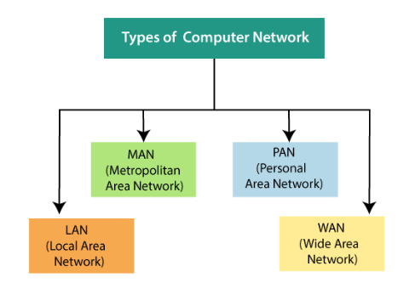
PAN (Personal Area Network)
A PAN is the smallest type of network, used for connecting devices within a few meters—typically around a person.
Examples:
- Bluetooth devices
- Smartwatch connected to phone
- Hotspot sharing
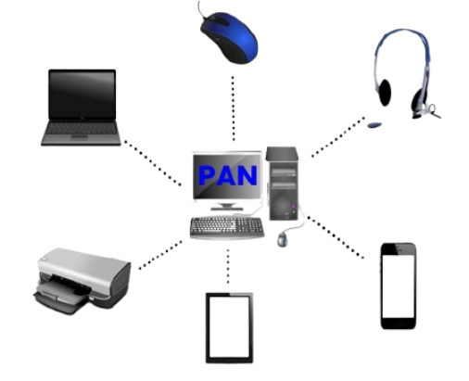
Types of PAN (Personal Area Network)
Personal Area Network is divided into two categories.
- Wired Personal Area Network: The USB is used to create a wired Personal Area Network.
- Wireless Personal Area Network: Wireless Personal Area Networks (WPANs) are the connection networks created by combining wireless technologies like WiFi and Bluetooth. It is a network with a short range.

LAN (Local Area Network)
• In a small network, such as a building or a small office, systems are connected.
• LAN network is low-cost.
• Token-ring technology is being used.
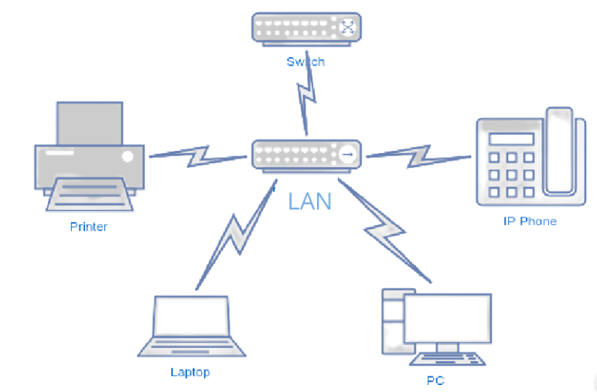
Two or more personal computers can be connected with nodes (wires or cables).
Data transfer is quick and well-rated.
MAN (Metropolitan Area Network)
• Cable TV Connection is an example of a network that can be connected within a city.
• Ethernet, ATM, Token-ring, and FDDI are some examples.
• MAN network has a wider range of applications.
• This network interface could be used to connect citizens to various organisations.
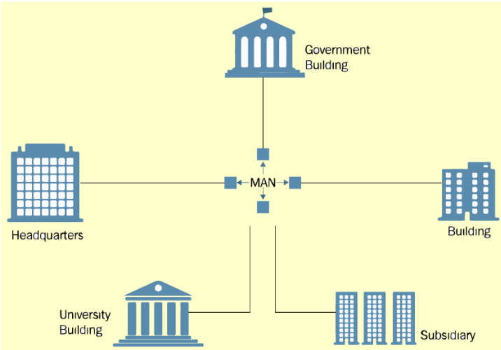
WAN (Wide Area Network)
• A network that spans a country or a larger group of individuals.
• The WAN network connects telephonic connections as well.
• The internet is the world's largest WAN, and it is mostly utilised by government entities to handle data and information.
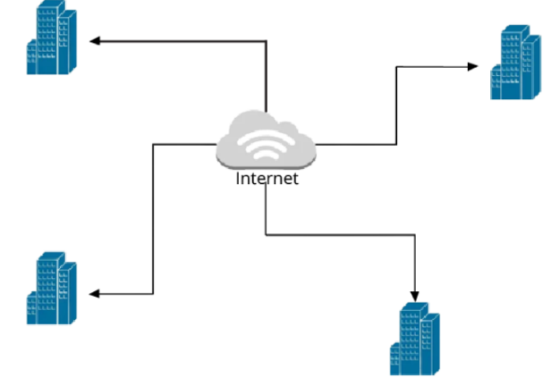
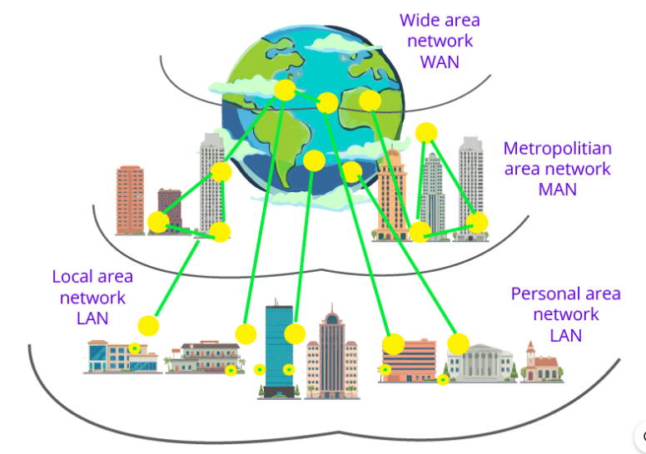
Additional Network Types
SAN (Storage Area Network)
A high-speed dedicated network that connects servers to shared storage devices. Used in data centres for fast and reliable storage access.
SAN (System Area Network)
A high-performance local network used for server-to-server or processor-to-processor communication. Common in clusters and supercomputers.
POLAN (Passive Optical LAN)
A LAN that uses fibre-optic cables and optical splitters instead of traditional Ethernet switches. Provides high speed and better efficiency.
EPN (Enterprise Private Network)
A private network created and owned by a company to securely connect multiple office locations or branches.
VPN (Virtual Private Network)
A secure, encrypted connection over the internet that allows users to access a private network remotely as if they were physically present there.

